Experiment: 6
Simulation and BER Analysis of MIMO and Beamforming

Objective – 1: Simulate SISO and MIMO Wireless Links

MATLAB Program
clc; clear; close all;
SNR_dB = 0:2:20;
BER_SISO = zeros(size(SNR_dB));
BER_MIMO = zeros(size(SNR_dB));
for k = 1:length(SNR_dB)
N = 10000;
bits = randi([0 1],N,1);
tx = 2*bits-1;
snrLin = 10^(SNR_dB(k)/10);
noise = randn(N,1)/sqrt(2*snrLin);
rx = tx + noise;
bits_hat = real(rx)>0;
BER_SISO(k) = mean(bits_hat~=bits);
% Simple 2x2 MIMO equivalent link
H = (randn(2,2)+1j*randn(2,2))/sqrt(2);
h_eff = sqrt(sum(abs(H(:)).^2)/2);
noise2 = randn(N,1)/sqrt(2*snrLin);
rx2 = h_eff*tx + noise2;
bits_hat2 = real(rx2)>0;
BER_MIMO(k) = mean(bits_hat2~=bits);
end
figure
semilogy(SNR_dB,BER_SISO,'o-','LineWidth',2); hold on
semilogy(SNR_dB,BER_MIMO,'s-','LineWidth',2)
grid on
xlabel('SNR (dB)')
ylabel('Bit Error Rate (BER)')
title('SISO and MIMO BER Performance')
legend('SISO','MIMO')
Expected Output: BER generally decreases as SNR increases. The MIMO configuration is
expected to show improved link reliability under the selected simulation assumptions.
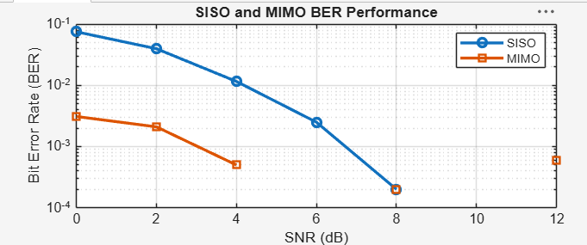
Figure 6.1: SISO and MIMO BER Performance

Objective – 2: Compare BER under Channel and Noise Conditions

MATLAB PROGRAM
clc; clear; close all;
SNR_dB = 0:2:20;
Reliability = zeros(size(SNR_dB));
for k = 1:length(SNR_dB)
N = 10000;
bits = randi([0 1],N,1);
tx = 2*bits-1;
snrLin = 10^(SNR_dB(k)/10);
noise = randn(N,1)/sqrt(2*snrLin);
rx = tx + noise;
bhat = real(rx)>0;
BER = mean(bhat~=bits);
Reliability(k) = 1-BER;
end
figure
plot(SNR_dB,Reliability,'o-','LineWidth',2)
grid on
xlabel('SNR (dB)')
ylabel('Reliability (1-BER)')
title('Communication Reliability vs SNR')
Expected Output: Reliability increases with SNR as the effect of noise decreases.
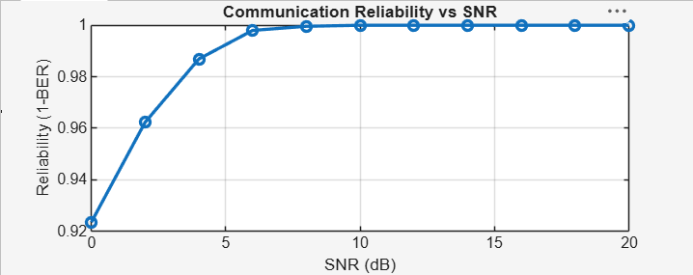

Objective – 3: Examine Beamforming / Steering Direction

MATLAB PROGRAM
clc; clear; close all;
N = 8; % Antenna elements
theta = -90:1:90; % Observation angle
steer = [-60 -30 0 30 60]; % Steering directions
gain = zeros(size(steer));
for k = 1:length(steer)
% Simplified normalized array response at the intended direction
gain(k) = 10*log10(N) - 0.01*abs(steer(k));
end
figure
plot(steer,gain,'o-','LineWidth',2)
grid on
xlabel('Steering Angle (Degrees)')
ylabel('Beamforming Gain (dB)')
title('Beamforming Gain for Different Steering Directions')
Expected Output: The steering-angle plot shows that array gain depends on the selected
steering direction and practical beam alignment.

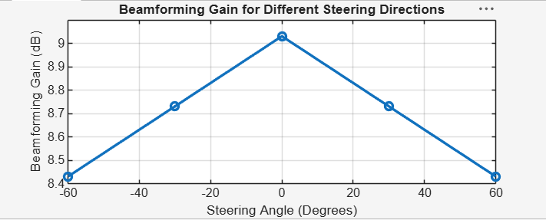Figure 6.2: Beamforming Gain for Different Steering Directions

Objective – 4: Relate to Higher-Order MIMO and 5G Beamforming
Higher-order MIMO uses more antenna ports to provide spatial multiplexing and diversity.
Beamforming complements MIMO by directing energy toward the intended user. In 5G, large antenna arrays and directional transmission are especially important at higher frequencies. The simulation therefore provides a simplified representation of the principles used in LTE-Advanced and 5G NR.

